**Rachel (“Rattles”)**

*Cinderella’s oldest stepsister. A short woman with a loud voice who thinks with her emotions rather than her head. Currently missing after running away from the prince’s arrest warrants.*

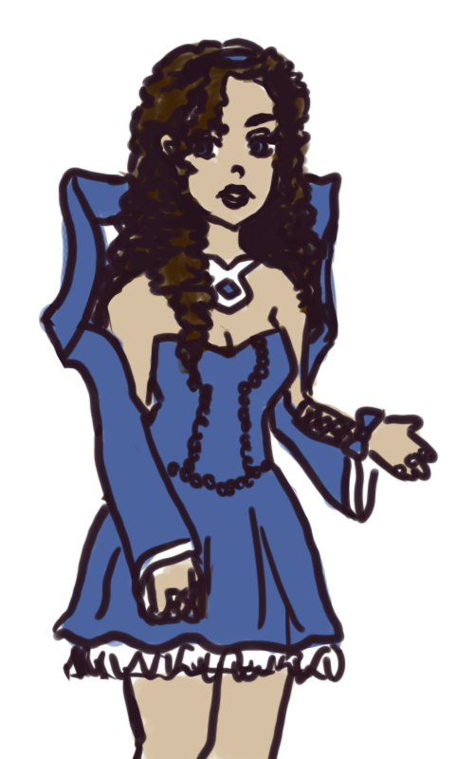

**Appearance**

Shortest out of the three sisters. Also petite - all in all, it makes for a look that causes many people to underestimate her or think of her as the classic, “pretty maiden” type. Because she gets sick and tired of this sort of treatment, she has a tendency to wear a perpetual scowl meant to intimidate other people. She makes up for her lack of height through an abundance in glittering jewels, although as of late, because their family has run into hard times, she has only managed to salvage a couple of her most precious gems. Her clothing resembles the latest styles of their kingdom - mostly Victorian, but with more tolerance for showing bare shoulders, ankles, and arms. In fact, the emerging fashion right now is knee-length skirts (I am seriously making this stuff up as I type). Her hair is curly - she takes great pains to curl them as tight as possible with curlers before going to sleep. She is a brunette.

**Personality**

After her mother remarried into Elizabeth’s family, Rachel took on the role of oldest sister a bit too enthusiastically. She prides herself in her ability to protect and care for her younger charges, but because she can be a little emotional and thick at times, this tends to get them all into a lot of trouble. The first out of the three of them who would throw herself into a street fight. Has a fairly foul mouth, but curbs her tongue when Cinderella is around because that girl is just “too damn innocent.” Ironically, she is also the one out of the 3 to care most about her appearance. She firmly believes that more jewelry means more beauty.